BEGINNER LEVEL 3 SQL TASK

You will be working on a sales dataset for this project, the data is currently in CSV format and you would need to import this into a database to be able to query the data using SQL.

Steps to create the database to be used for this task on your local machine:

1. Install Mysql workbench
2. Download the following [CSV files (products, baskets, basketproducts data)](https://drive.google.com/drive/folders/1G8r8jzXHxlJscfMNR3_26rDmOmRdeJGo?usp=sharing)
3. Create a new schema on MySQL workbench (you can name it however you like)
4. Add these CSV files as separate tables inside your new schema
5. Start querying the database

Follow this [tutorial](https://bimie.medium.com/create-your-own-database-using-csv-files-7138e947ba1c?source=friends_link&sk=6ee6021fb1357f1e777765bba24a0c00) for a better understanding of how to set up the database.

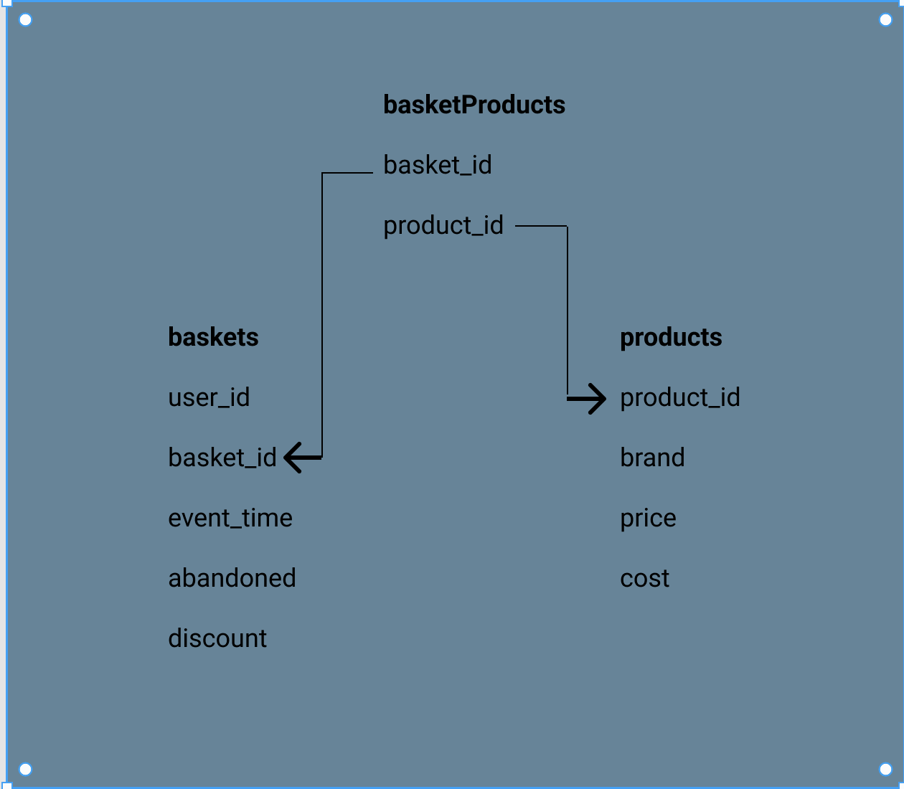

Schema

QUESTIONS

1. How many users are in the database?
2. How many baskets are in the database?
3. What is the percentage of baskets that were abandoned?
4. What is the percentage of baskets sold with discounts?
5. What are the discounts?
6. How many baskets are in each discount group?
7. The highest revenue was recorded on which day of the week?
8. The highest revenue was recorded on which day?
9. Top 10 most profitable products and their brands
10. Top 5 most profitable brands